We are a non-profit medical clinic offering help and hope to those facing an unplanned pregnancy. All of our services are free of charge.
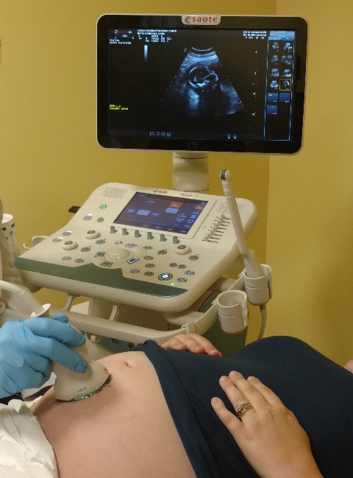

Services:
Pregnancy Testing
Ultrasounds

Classes:
Pregnancy
Childbirth
Parenting Classes

We strongly believe in equipping those who carry to term. Our classes provide essential tools and foundations to build upon as they begin their parenting journey. Ours is an “earn while you learn” program. Participants “shop” in our on-site baby boutique with credits they earn by completing classes.

Web Sites - carenetfitchburg.net and friendsofcarenetfitchburg.org

National Affiliation – This center is an affiliate of Care Net which is based in Virginia. The center is also an affiliate of NIFLA (National Institute of Family and Life Advocates) whose headquarters are also based in Virginia. NIFLA provides excellent medical clinic guidelines and legal oversight. Local Information - The center is a 501(c) (3) with all services offered at no cost to the client. We have been in operation in Fitchburg since 1976. The present staff and board represent many different Christian Churches both independent and denominational. The center is a member of the North Central Mass Chamber of Commerce. We are supported by local individuals, churches and businesses. The national affiliations do not provide funding. Licensed Medical Clinic – Care Net PRC is licensed by the Massachusetts Department of Public Health as a medical clinic offering pregnancy testing and ultrasound services. Care Net Pregnancy Resource Center, out of concern for the health of women and the value of all human life does not refer for abortion services.

